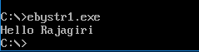
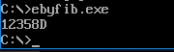
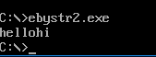
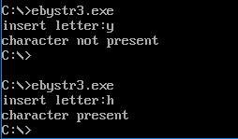
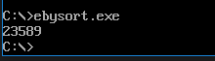

10 a)
.MODEL SMALL
.DATA
LIST DB 2h, 9h, 8h, 5h, 3h
.CODE
MOV AX, @DATA
MOV DS, AX

MOV CL,05h
L1: MOV CH, 05h
MOV SI, OFFSET LIST
L2: MOV AL, [SI]
INC SI
CMP AL, [SI]
JC SKIP
XCHG AL,[SI]
DEC SI
XCHG AL, [SI]
INC SI
SKIP: DEC CH
JNZ L2
DEC CL
JNZ L1

MOV CX, 05H
MOV SI, OFFSET LIST
L3: MOV AL,[SI]
CMP AL,0Ah
JGE ALPHA
ADD AL,30h
JMP INCRE
ALPHA: ADD AL,37h
INCRE: MOV DL,AL
MOV AH,02H
INT 21H
INC SI
LOOP L3
MOV AH,4Ch
INT 21h
END
10b)
.model small
.data

a1 db 00h
b1 db 01h
c1 db 06h
d1 db 06 DUP(?)

.code
mov ax,@data
mov ds,ax
mov si,offset a1
mov al,[si]
mov si,offset b1
mov bl,[si]
mov si,offset c1
mov cx,[si]
mov si,offset d1
L1: add al,bl
mov [si],al
mov al,bl
mov bl,[si]
inc si
loop L1
mov cx,06h
mov si,offset d1
L2: mov al,[si]
cmp al,0Ah
jge AlPHA
add al,30h
jmp incre
ALPHA : add al,37h
INCRE: mov dl,al

mov ah,02h
int 21h
inc si
loop L2
mov ah,4ch
int 21h
END

11 a)
.model small
.data
msg db "Hello Rajagiri$"
.code
mov ax,@data
mov ds,ax
lea dx,msg
mov ah,09h
int 21h
mov ah,4ch
int 21h
end

11 b)
.model small
.data
msg1 db "hello$"
msg2 db "hi$"
.code
mov ax,@data
mov ds,ax
lea si,msg1
lea di,msg2
mov al,'$'
UP: cmp al,[si]
jz next
inc si
jmp up

NEXT: cmp al,[di]
jz EXIT

mov bl,[di]
mov [si],bl
inc si
inc di
jmp NEXT
EXIT: mov [si],al
lea dx,msg1
mov ah,09h
int 21h
mov ah,4ch
int 21h
END

11 c)
.model small
.data
msg db "hello world$"
msg1 db "character present$"
msg2 db "character not present$"
msg3 db 10,13,'$'
ins db "insert letter:$"
.code
mov ax,@data
mov ds,ax
lea si,msg
lea dx,ins
mov ah,09h
int 21h

mov ah,01h
int 21h

lea dx,msg3
mov ah,09h
int 21h

mov bl,'$'

UP: cmp bl,[si]
jz exit
cmp al,[si]
jz print
inc si
jmp UP

PRINT :lea dx,msg1
mov ah,09h
int 21h
mov ah,4ch
int 21h
EXIT: lea dx,msg2
mov ah,09h
int 21h
mov ah,4ch
int 21h
END

